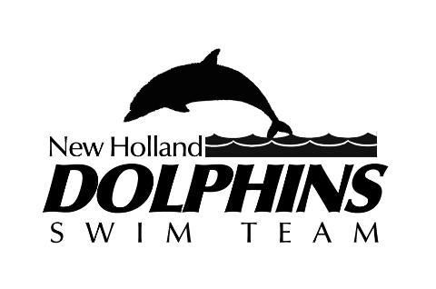
Parental Waiver and Consent Form
As the parent or legal guardian of the child named below, I hereby give my full consent and approval for my child to participate as a team member with the New Holland Dolphins Swim Team.
I understand that there are certain risks of injury inherent in the practice and play of this sport, as well as in traveling and other related activities and I am willing to assume these risks on behalf of my child. I hereby certify that my child is fully capable of participating in the designated sport and that my child is healthy and has no physical or mental disabilities or infirmities that would restrict full participation in these activities, except as listed below.
In addition to giving my full consent for my child’s participation, I do herby waive, release and hold harmless the New Holland Dolphin Swim Team, their Board of Directors, Line officers, Coaches, drivers and Sponsors for any injury that may be suffered by my child in the normal course of participation in the designated sport and activities incidental there to, whether the result of negligence or any other cause.

__________________________________________________________________________________________________________________________________________________________________________
(Any Medical Issues that should be made aware of to the Team)
___________________________________________ ______________
(Name Of child) (Date)
New Holland Dolphins Swim Team
(Name of Organization)

___________________________________________
(Parent Signature)

